**ASSIGNMENT # 2**

**Question #01: Write the programs of the following problems in c/c++ code:**

1. **Generate the following output without using any loop. Just use escape sequence.**

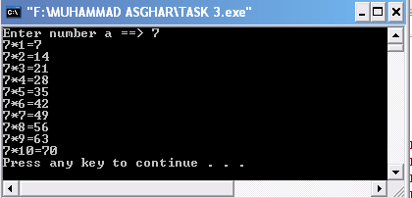

**#include <iostream>**

**using namespace std;**

**int main()**

**{**

**int a;**

**cout << "Enter a number ==> \a";cin>>a;**

**cout <<a<<" * 1 = "<<a*1<<"\n\a";**

**cout <<a<<" * 2 = "<<a*2<<"\n";**

**cout <<a<<" * 3 = "<<a*3<<"\n";**

**cout <<a<<" * 4 = "<<a*4<<"\n";**

**cout <<a<<" * 5 = "<<a*5<<"\n";**

**cout <<a<<" * 6 = "<<a*6<<"\n";**

**cout <<a<<" * 7 = "<<a*7<<"\n";**

**cout <<a<<" * 8 = "<<a*8<<"\n";**

**cout <<a<<" * 9 = "<<a*9<<"\n";;**

**cout <<a<<" * 10 = "<<a*10<<"\n";**

**return 0;**

**}**

1. **Using the increment and decrement operator generate the following output: You can assign integer value 9 in a variable and then apply increment and decrement operator:**

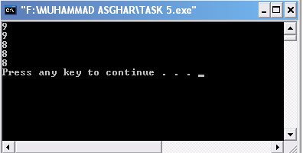

**#include <iostream>**

**using namespace std;**

**int main()**

**{**

**int a=9;**

**cout<<a<<"\n";**

**--a;**

**a++;**

**cout<<a<<"\n";**

**a--;**

**cout<<a<<"\n";**

**--a;**

**a++;**

**cout<<a<<"\n";**

**a--;**

**++a;**

**cout<<a<<"\n";**

**return 0;**

**}**

1. **Write a program that input your age in years and convert the age in months, days, hours, minutes and seconds and then print all these computed values on screen.**

**#include <iostream>**

**using namespace std;**

**int main()**

**{**

**int a;**

**cout<<"enter your age in years ";cin>>a;**

**cout<<"Your age in months is "<<a*12<<endl;**

**cout<<"Your age in days is "<<(a*12)*365<<endl;**

**cout<<"Your age in hours is "<<((a*12)*365)*24<<endl;**

**cout<<"Your age in minutes is "<<(((a*12)*365)*24)*60<<endl;**

**cout<<"Your age in seconds is "<<((((a*12)*365)*24)*60)*60<<endl;**

**return 0;**

**}**

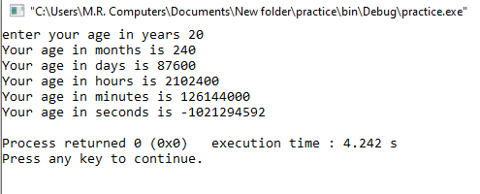

1. **Write a program which takes five marks of the students in 5 different integer variables and calculate the percentage of the student this percentage value must be stored in float variable and then print all values including 5 marks, sum of marks and percentage.**

**#include <iostream>**

**using namespace std;**

**int main()**

**{**

**float maths, english, pst, physics, chemistry;**

**cout<<"Enter marks of Maths \a";**

**cin>>maths;**

**cout<<"Enter marks of English \a";**

**cin>>english;**

**cout<<"Enter marks of Pst \a";**

**cin>>pst;**

**cout<<"Enter marks of Physics \a";**

**cin>>physics;**

**cout<<"Enter marks of Chemistry \a";**

**cin>>chemistry;**

**cout<<"\nMarks obtained in maths are \a"<<maths<<endl;**

**cout<<"Marks obtained in English are "<<english<<endl;**

**cout<<"Marks obtained in Pst are "<<pst<<endl;**

**cout<<"Marks obtained in Physics are "<<physics<<endl;**

**cout<<"Marks obtained in chemistry are "<<chemistry<<endl;**

**cout<<"Total marks obtained are "<<maths+english+pst+physics+chemistry<<" out of 500"<<endl;**

**cout<<"Percentage is "<<((maths+english+pst+physics+chemistry)/500)*100<<"%"<<endl;**

**return 0;**

**}**

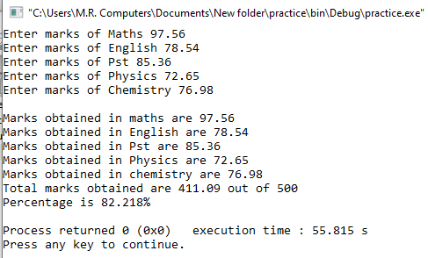

1. **Write a program to solve the following quadratic equation which is having 3 input variables a, b, c. Assign float values of your choice into a and b variables and take the integer input value at run time in c variables. You have to evaluate the formula two times with – and + values so you have two output values must be saved in x1, and x2 variable.**

**#include <iostream>**

**#include <math.h>**

**using namespace std;**

**int main()**

**{**

**float a,b,c,x1,x2;**

**cout<<"Enter the coefficient of x^2 "<<endl;**

**cin>>a;**

**cout<<"Enter the coefficient of x "<<endl;**

**cin>>b;**

**cout<<"Enter the value of constant "<<endl;**

**cin>>c;**

**x1=(-b+(sqrt(pow(b, 2) - 4*a*c)))/(2*a);**

**x2=(-b-(sqrt(pow(b, 2) - 4*a*c)))/(2*a);**

**cout<<"The first root of the quadratic equation is "<<x1<<endl;**

**cout<<"The second root of the quadratic equation is "<<x2<<endl;**

**return 0;**

**}**

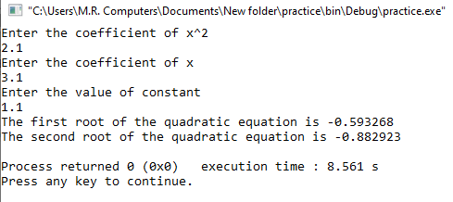

1. **Solve the following equation Use the precedence rules for the arithmetic operators’ usage**

**A = 7.7b ( xy + a ) / c - 0.8 + 2b (d)**

**( x + a ) (1 / y )**

**#include <iostream>**

**using namespace std;**

**int main()**

**{**

**float A, a, b, c, d, x, y;**

**a=1;**

**b=2;**

**c=3;**

**d=4;**

**x=5;**

**y=6;**

**A=(7.7*b*(x*y+a)/c-0.8+2*b*d)/((x+a)*(1/y));**

**cout<<"Answer to the equation is "<<A<<endl;**

**return 0;**

**}**

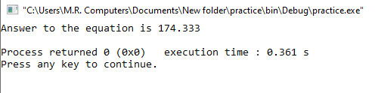

1. **Write a program to input three integer numbers, compare these three numbers if they are equal. Use “nested if statement” and print the message “All values are equal” if they all are equal. Otherwise print the message “They all are not equal”.**

**#include <iostream>**

**using namespace std;**

**int main()**

**{**

**float a,b,c;**

**cout<<"Enter first number \n";**

**cin>>a;**

**cout<<"Enter second number \n";**

**cin>>b;**

**cout<<"Enter third number \n";**

**cin>>c;**

**if (a==b)**

**{**

**if(a==c)**

**if(b=c)**

**cout<<"All values are equal"<<endl;**

**}**

**else**

**cout<<"All values are not equal"<<endl;**

**return 0;**

**}**

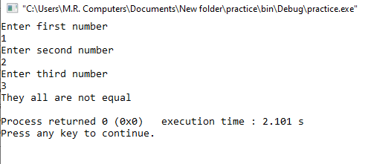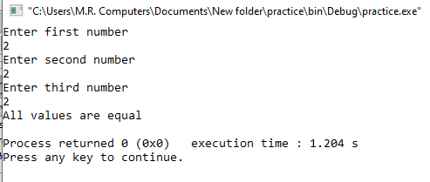

1. **Write a program to input a single letter in char variable. if "m" is input print "You are a male" otherwise print "You are a female".**

**#include <iostream>**

**using namespace std;**

**int main()**

**{**

**char a;**

**cout << "Enter m for male and any other for female" << endl;**

**cin>>a;**

**if (a=='m')**

**cout<<"You are a male"<<endl;**

**else**

**cout<<"You are a female"<<endl;**

**return 0;**

**}**

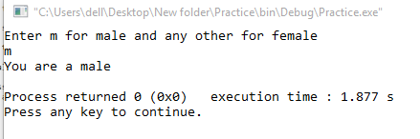

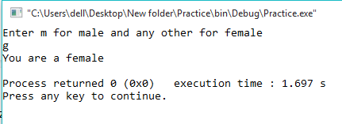

1. **Write a program to input a single character and print a message "its a vowel" if it is a vowel otherwise print "its a consonant".  
   Use switch statement.**

**#include <iostream>**

**using namespace std;**

**int main()**

**{**

**char a, lowercasevowel, uppercasevowel;**

**cout << "Enter a letter" << endl;**

**cin>>a;**

**lowercasevowel = (a=='a' || a=='e' || a=='i' || a=='o' || a=='u');**

**uppercasevowel = (a=='A' || a=='E' || a=='I' || a=='O' || a=='U');**

**if (lowercasevowel || uppercasevowel)**

**cout<<"Its a vowel"<<endl;**

**else**

**cout<<"Its a consonant "<<endl;**

**return 0;**

**}**

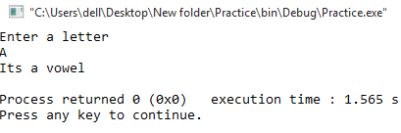

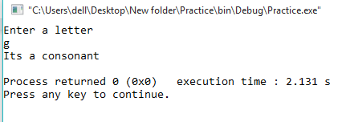

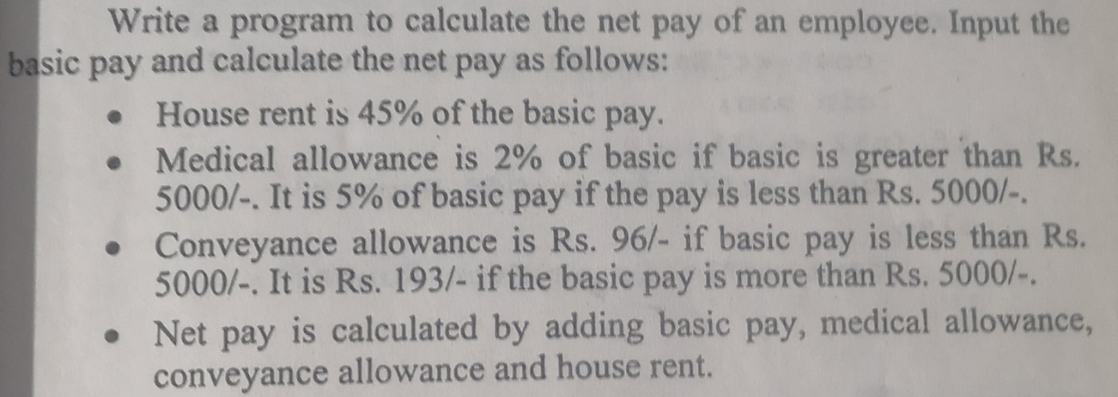

**#include <iostream>**

**using namespace std;**

**int main()**

**{**

**float basic_pay, net_pay, house_rent, medical, conveyance;**

**cout<<"Enter basic pay"<<endl;**

**cin>>basic_pay;**

**house_rent=0.45*basic_pay;**

**if (basic_pay<5000)**

**medical=0.05*basic_pay;**

**conveyance=193;**

**if (basic_pay>5000)**

**medical=0.03*basic_pay;**

**conveyance=96;**

**net_pay=basic_pay+house_rent+medical+conveyance;**

**cout<<"The net pay of the employee is "<<net_pay<<endl;**

**return 0;**

**}**

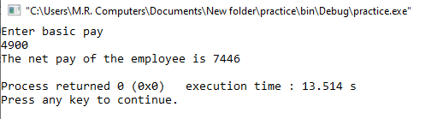

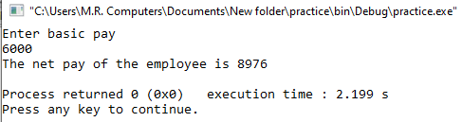

**Fill in the blanks**

**i.  A relational expression returns only one value. It may be**true or false**.**

**ii. In C++**==**sign is used to compare if the two value are equal.**

**iii.  The statements in curly brackets are also known as**a block or compound statement.

**iv.  The**if **structure is used to execute one task when the given condition is true and other task when the given condition is false.**

**v. If the “if “ statement comes under another “ if “ that is called** nested if**.**

**vi. The**switch**statement is used for multiple selections.**

**vii. In the switch statement, if no case is matched then the statements under the keyword** default **will be executed.**

**viii. The**break**statement is used to exit from the body of switch structure.**

**ix.   The** switch **is used to alternative of simple if-else.**

**xii. The**break**statement is an unconditional control statement.**

**xi)  if x=2, then after executing the statement "x = x++;"the value in x will be :**3

**xii) if x=2, the after executing the statement "x+=10;", the value of x will be**12

**xiii) if x=10;, then after executing the statement "x*=++x;", the value of x will be** 121

**i) The expression 15%6 will return**3

**ii) Each statement in C++ is terminated with**; (the terminator)

**iii) The**// and /* */**is used to give comments in C++ program**

**iv) The increment operator that is used before the variable is called**Pre-increment

**v) The  -- operator is used to subtract 1 from the value of an integer variable.**

**vi) if x=3 the after executing the statement "x=++x+(++x);" the new value of x will be**10

**vii)if x=5 the after executing the statement "x*=10;" the value of x will be**50